EC2
Improving Cultures, Ethically!

Business Plan

Ethical Corporate Culture
Part1: The Executive Summary
Mission statement
Ethical Corporate Culture seeks to provide awareness of ethical issues and instill those lessons into the minds of corporate employees to raise consciousness of ethical challenges and the risks they pose to the well-being of corporations as a whole.
Anticipated Start Date
EC2 is seeking to begin operations by June 2011.
Founders:
Mike Delzoppo – co-founder
William Cosgrove – co-founder
Number of employees
As the business is forming, we are operating under a structure of two employees, both of whom are co-founders of the organization. We are in the process of procuring outside funds, likely from silent partners.
Several services will be provided by contractors, and we may eventually start hiring employees for administrative duties. Those plans, however, are yet to be determined.
Locale
Ethical Corporate Culture (EC2) is in the process of being founded in the greater Cleveland area. We anticipate that we will grow to have local subcontractors across the nation, but the headquarters will remain in northeast Ohio for the foreseeable future.
Services Rendered
The service provided will be a curriculum of activities resulting in an ethics certification program, which will consist of the following activities:
- In-class training (including legal aspects from government perspective)
- Web-based training
- Online exams
- Case studies/ethics simulations
- Observations from real-world scenarios (self and others)
- Review of company code of ethics (done by internal company person, likely from HR)
Also, there will be different levels of certification. The first level being that this person has fulfilled the requirements of the curriculum and received a certificate. The next level requires an extended certification process, so that this person can act as a “corporate coach” in ethical decision-making. The final certification is that of an “ethical corporate auditor.”
EC2 will contract professional ethics speakers to give in-class presentations to the customer, and will contract similar professionals for the development of the web-content and exams. Also, we will be including government speakers on behalf of the new Cuyahoga County government and Ohio Ethics Commission. This will add legal substance to the content, build credibility, and form an improved relationship with the community.
The business model that EC2 will be following is similar to that of a Six Sigma certification. EC2 will own the curriculum of the steps needed for certifications, but other independent companies can license the rights to deliver the content. Initially, however, EC2 will be delivering their own training sessions to their customers.
Table of Contents
Market Analysis - pg 3
Company Description - pg 8
Organization & Management pg 9
Marketing & Sales Management pg 10
Our Service pg 11
Funding Request pg 14
Appendix pg 15
Part2: Market Analysis
Background
Ethical decision making is a daily necessity in organizations. There are an infinite number of motivating factors to influence leaders and other decision makers to make unethical decisions. Unethical decisions can have major negative implications on the organization as a whole, up to the point of causing the organization to dissolve. The following are a few examples to help explore this concept (Johnson):
- Abusing power - Leaders can be tempted to abuse the power that is granted to them in their position. The power can cloud judgment in differentiating the needs of themselves compared to the duties to others. This problem can have numerous effects on followers, including losing trust. An obvious example of this is Enron leadership telling the Audit Department “you’re wasting your time to audit the books.”
- Hoarding privileges - Leaders of companies have outlandish spending on themselves, even in retirement packages at the expense of the company, yet often require employees to track spending down to the penny.
- Mismanaging information - One example is the tobacco companies, who sponsored research indicating that smoking cigarettes was not safe and testified that they were, in fact, safe, perhaps to protect their own job and stake in the company. As another example, Pat Tillman’s death from friendly-fire was covered up as an attempt to avoid bad publicity through the media.
- Acting inconsistently - Leaders can provide preferential treatment to the best employees. This can provide motivation to those specific employees, but has the downside of decreasing morale for the rest of the team. Similarly, investment banks have given privileged information to their more profitable customers.
- Misplacing or betraying loyalties - Kenneth Lay, of Enron, assured the employees that the company was in good standing as it was heading directly toward bankruptcy.
These are just a few of the ethical challenges faced daily by leaders and decision makers. Overcoming all of these (often several of them working in tandem) can be a burdensome task for individuals to take on without formal training. The process of overcoming an ethical dilemma will be made much simpler for decision makers by providing them with training, support from ethical “coaches,” and reinforcement from the corporate culture.
This training program is the basis for our company, Ethical Corporate Culture (EC2). EC2 is building an “ethical decision making” curriculum that will assist leaders and decisions makers to act ethically in the corporate environment.
Industry Description and Outlook
Change in monthly employment for the Cleveland area from December 2009 to October 2010 has shown a geometric average over eleven months of approximately -1.3% (Employment 2010). While this number alone suggest the local market is not open to new business, it is substantial when considering that in December 2009 the monthly change in employment was -5.3%. Moreover, within the past five months employment has risen approximately) 0.80%. See Figure 2.1.
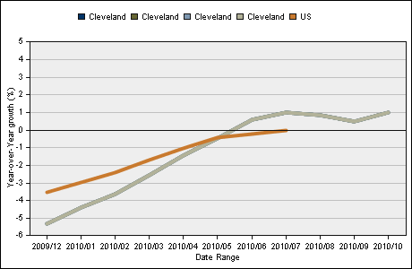
Figure 2.1
More specifically, Cleveland is an area where government, health organizations, public services, and manufacturing represent a large part of our economy, i.e. Cleveland alone has 10-20% of the national manufacturing jobs within the largest national employment sectors (Ohio Grantmakers 2004). Examining the geometric averages for the months from June 2010 to October 2010, monthly change was 4.9% for manufacturing, 0.6% for utilities, 3.2% for educational/health services, and -2.1% for government. This winter will include a significant amount of new hires despite the unemployment rate staying slightly under 10%. Also, the decrease in local government officials was a structural change reflecting efforts to reduce the local budget deficit. See Figure 2.2.
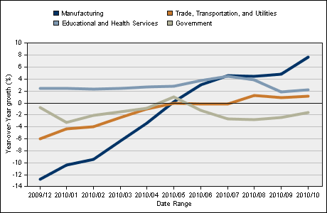
Figure 2.2
These two charts provide an optimistic look entering 2011. As government is reduced, more people will enter the workforce and monitor the actions and status of local companies. Concurrently, major Cleveland sectors are hiring jobs in both blue collar and white collar professional sectors. As will be discussed below, the local government is transforming itself according to the new county charter. In the context of the county corruption case and mortgage crisis, the charts suggest a diverse amount of people employed by companies and governments that will be more publicly scrutinized than in previous years. An ethics-based company would be the vehicle to bring the new government, businesses, and employees together through shared ethical views as macroeconomic issues are being addressed.
Other Providers
Ethical Leadership Group - This company provides consultation and training to corporate employees. They offer no “curriculum” to get a certification, nor levels of certification.
Josephson Institute - This group has a focus on providing training to reduce legal exposure. They provide ethical audits, training, and consulting. They offer no certification programs and do not rely as much on internal leaders to audit their own culture.
Vincent DiNoricia - This independent gentleman is an author, consultant, and speaker. He focuses primarily on teaching, not certifying.
IMC USA - This organization awards certifications to those who are eligible to become a consultant, or a certificate to a firm that sells consulting. It does not certify individual decision makers who have completed an ethical decision making curriculum. However, the consultants contracted by EC2 should be IMC certified.
Marketing differentiations
The other providers above merely offer components (e.g. training, consulting) of the overall curriculum presented by EC2. EC2 is a superior service, based on the concept of a full-scale certification process for both individual employees and corporations as a whole. Also, the creation of different certification levels for ethical support, along with the process of improving the culture of the corporation, lead to a strong competitive advantage.
Currently, the Cuyahoga County Transition Advisory group is promoting a Code of Ethics to be adapted and included in county charter once the new commission and its officers take their positions (Cuyahoga 2010). Such topics to be included in the Code of Ethics are whistle-blowing, improper acceptance of gifts, and establishment of a Board of Ethics.
For the past two months, nearly every daily edition of The Plain Dealer newspaper contained one or more articles pertaining to the current Cuyahoga County corruption or incoming city commission (Search 2010).
Customer (Corporation) Benefits
“Under that doctrine, an organization is responsible for the wrongful acts of its employees, as long as the employees were acting in their official capacity. The 1991 Guidelines represent that employees and agents of organizations are expected to be trained and counseled to act in a lawful and ethical fashion. The organization shares a degree of culpability if an employee or agent acts in an unlawful manner, even if the organization did not know of or approve of their actions.” (Alpert)
This statute was further refined in 2004 to require corporations to continually assess their code of conduct, create clear roles of ethical leadership, required ethical training for all employees, and require employees to report misconduct. (Hess) Each of these requirements adds further justification for a corporation to sign up for the services of EC2.
No matter the size or the profitability of the company, incorporating a strong ethical culture and compliance program will create a fluid, synergized firm that, in turn, may lead to significant income generation and growth. Consider the following graph, taken from the business ethics international think-tank Ethisphere. The graph labeled WME reflects the return of”World’s Most Ethical” businesses versus equity indices. The “WME” title was given to companies who demonstrated ethical compliance programs, had a strong reputation, followed governance, and practiced corporate responsibility (World’s 2010). Consider the tremendous gains, or even the recognition of a positive return, in 2010 when the S&P 500 was providing negative returns.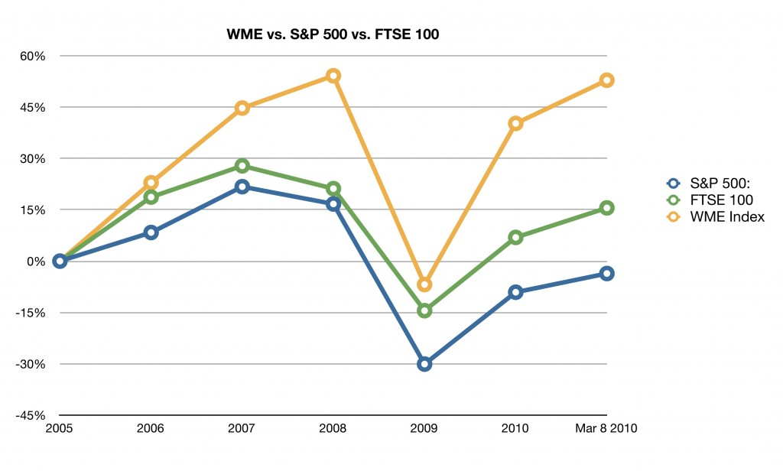
-graph from http://ethisphere.com/wme2010. Our company does not manage the profitability and financial well-being of any company. This graph is used for illustrative purposes only; we do not suggest the graph for making investment decisions.
Aside from profitability in the marketplace, consider profitability from a legal standpoint (avoidance of expense). As an executive for the workplace, ethics should not be seen only as a way to recruit employees or encourage worker morale. In the beginning of 2010, Pfizer Inc. was fined $2.3 billion for its actions against a former employee and “whistleblower” and illegal sales of a prescription medicine (Drug 2010). In addition, based on a Fortune 1000 listing, this fine alone was more than 25% of the listed net income (Fortune 2010); it was also more than 116% of cash and cash equivalents of the company (Pfizer 2009). More than likely, costs may have been reduced, equipment sold, people laid off, and subsequently, production may be reduced to pay the fine.
Giving executives at a company the “auditor” role (highest level of certification), they can ensure that the corporate ethics training and values match the culture. The opposite was the case with Enron, as they had “model code of ethics… [however,] the values of the vision statement appeared exactly opposite of the true culture that existed there.” (Hess)
Part3: Company Description
Ethical Corporate Culture
A study on multi-national firms in Taiwan was performed examining the relationship between different the companies and their respective roles with their foreign subsidiaries and respective cultures and governments (Wu 2001). While Ethical Corporate Culture will initially focus within the Northeast Ohio area, it is in the best interest of the company and corporations to consider various participants and related individuals. For example, Cuyahoga County will enter 2011 with a new county commission, which will represent both a more decentralized and more inclusive government body. Also, during the past several years, banking and financial industries’ processes have changed greatly due to the economic recession, sale of a locally-based company, and increased oversight. Therefore, replace China and Vietnam with Cleveland and eastern suburbs. An additional box may be added titled County/local risk, listing the same factors as the Country risk box.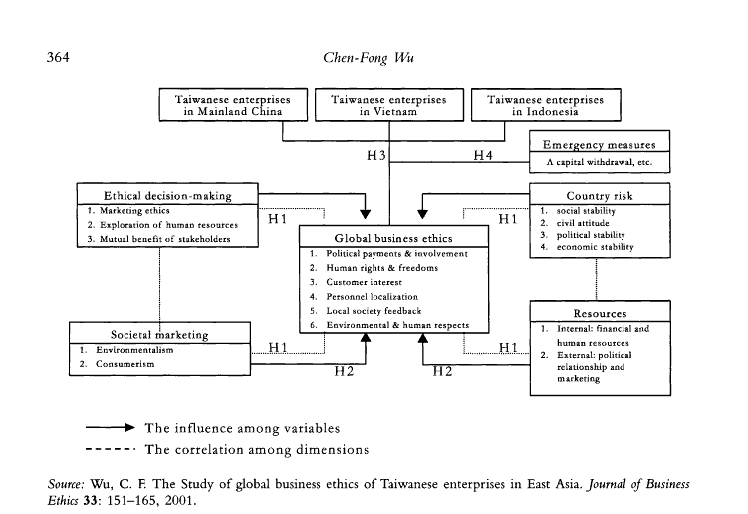
Certification Levels
Level 1: Certified Individual Decision Maker – ability to make ethical, independent decisions.
Level 2: Certified Coach – ability to act as a guide/resource for individuals who need assistance in decision making (could be HR consultants with this designation).
Level 3: Certified Auditor – ability to “coach the coaches” and responsibility to verify that the corporate ethics code is instilled into the corporate culture. This person will keep track of the relationship of the “code” and culture, as it will be reviewed tri-annually by the certification board. (Likely to be senior staff members from various departments (or delegates): CHRO, CFO, business unit VP)
Corporate certification: The corporation as a whole can receive certification. To do this, the following requirements must be met:

- At least 50% of the exempt employee staff must be certified
- The “Level 2” (coach) to “Level 1” ratio must be no greater than 10:1
- The “board” of Level 3 shall be of sufficient size to monitor corporate culture in perspective of the code of ethics. Recommendation is a ratio of 10:1 of coaches to auditors. One of these members must be designated as “chairman of the ethics board.”
Renewing the corporate certification: Every three years, the corporation must renew the corporate certification via a review process. In this process, the Level 3 “auditors” will be the point person (people) to meet with the certification board. Also, similar to the CFO/CEO being held legally accountable with SOX compliance, the “auditor” role can be held accountable for ethical decisions within the organization, especially in cases of “gross negligence.”
Part4: Organization and Management
Ownership Information
Legal structure of business: Limited Liability Corporation
Owner names: William Cosgrove (50%) and Mike Delzoppo (50%), who are each founders of the company. They are prepared to release a portion of ownership to investors, and would entertain the idea of an active partner to attain ownership in exchange for the implementation of operational functions. This person would need to be a subject matter expert, who can work to build the foundation of the curriculum and deliver in-person consultation, and must also be certified or seeking IMC USA certification.
The ownership rights are designated by privately held common stock.
Management Profiles
William Cosgrove -
Position: Head of finance and strategic development
Primary Duties: Examine and evaluate financial position and performance of company
Education: Bachelor of Business Administration, Finance, Miami University of Ohio
Unique experience and skills: Candidate for the CFA Level I Exam; Micro-Enterprise Developer as Peace Corps Volunteer
Prior employment: Customer Service Representative at PNC Bank, N.A.
Special skills: Fluency in Spanish, experience with entrepreneurship in developing nations
Past track record: Foreign representative in South America as member of Peace Corps; small and large group organization; educator in finance, accounting, marketing, and management; Graduate student in Ethical Leadership
Community involvement: Junior Achievement volunteer
Compensation basis and levels: $30,000/year base, plus sales commission of 10%
Mike Delzoppo -
Position: Head of marketing and operations
Primary Duties: Procure customers, hire consultants, deliver on the mission
Education: Bachelor of Business Administration, Cleveland State University
Unique experience and skills: 10 years corporate experience in management, consultant roles
Prior employment: Progressive Insurance, 2001 - 2010
Past track record: Leading teams, Ethical standards of integrity, Graduate student in Ethical Leadership
Compensation basis and levels: $30,000/year base, plus sales commission of 10%.
Part5: Marketing and Sales Management
Overall Marketing and Sales Strategy
EC2 will locate contractors (qualified consultants) with IMC USA certification and negotiate cost structure for their services regarding in-class training. Also, EC2 will work with these consultants for development of web-based training courses, exams and the development of the curriculum itself.
To build awareness and generate sales, EC2 will be taking several actions, including:
- publish a website with key tags that will come up on search engines
- ads in business magazines/websites
- directly contacting large companies to make them aware of our services
- create profiles on LinkedIn and Facebook
- presentations at business seminars
- networking through existing colleagues
- referrals from previous customers
These actions will be sped up or slowed down depending upon the ability for EC2 to meet existing customer demands.
In addition to targeting Fortune 1000 organizations, we will also be marketing to companies with high publicity. For example, there have recently been scandals with NBA referees influencing the games and NFL coaches “spying” on other teams practicing. Furthermore, players in several professional sports are being found guilty of using performance-enhancing drugs. Each of these scenarios presents an opportunity for ethical training. The notion of a major sports organization embodying such training will be a great public relations move for them to enhance the semi-broken credibility of today, and will yield publicity benefits for EC2 as well.
Part6: Our Service
Detailed description of service
This service provides knowledge to corporate employees about the benefits and risks of ethical decision making. After having been educated within this curriculum, passed the exams, and receiving certification, the employees will feel empowered and even a sense of duty to make ethical decisions. Furthermore, it will be very clear who the employees can seek out for guidance on ethical dilemmas that they may be facing (i.e. the “ethical coaches”).
The customers can expect to provide a training location and computers for their employees going through the training. If that cannot be accommodated, then space at a local college/university can be sought out as alternate training location. Also, an HR consultant from the customer should be provided to work with EC2 to help integrate course content into the customer’s company code of conduct/ethics.
After the training courses, employees who have been trained will be required to cite examples of ethical dilemmas they have been a part of or witnessed, document what they did or saw, and bring those back to the next in-class training session. The employees must have sufficient detail regarding the incidents and have acted appropriately in order to gain credit for that part of the curriculum.
EC2 will provide all training materials (including web-based), in-person consultant(s), exams, certificates, and an option for a consultant to make quarterly customers visits. The curriculum will generally flow as outlined below.
Level 1 Certification (Decision Maker)
After having been certified in the Level 1 curriculum, the improved employee decision making will help to reduce corporate risk. One of the biggest risks of unethical behavior is company dissolution (e.g. Enron) or very large fines (e.g. Phizer). Furthermore, the company can become more attractive to customers and potential employees, which can help to reduce costs (lower employee turnover) and increased sales. These employees will have an option to pursue certification to become a coach.
Level 2 Certification (Coach)
Coaches are a critical part of the ethical decision making process. They have a great deal of responsibility to not only make ethical decisions themselves, but also to support others in the ethical decision making process. This layer of support leaves no excuses to the decision makers for the decisions made when ethical dilemmas are presented.
Level 3 Certification (Auditor)
After meeting the required number of auditors and ratio of coaches to certified decision makers, a company can be eligible for a “corporate certificate,” which indicates that the company has met all requirements within the organizational structure. This certificate can provide a positive public relations message, further enhancing public image.
Copyright, Patent, Trade Secret Info
The content of the web-based training courses, exams, and in-class presentations will all be copyrighted. The company will not pursue any patents or trade secrets as part of the initial organizational structure.
R&D activities
EC2 is continuing to research the most effective cases in real life that can be brought into the training environment. Those cases with high relevance, high impact, but may only be seen as modest ethics violations initially are currently thought to be the most effective examples. The ongoing research will either validate the approach or result in a change in the case approach. Once these cases are identified, the web-based material and in-class material will be developed to parlay off of these cases. EC2 sees this approach on-going through the foreseeable future in an effort to ensure the most effective training is presented to its corporate customers.
Part7: Funding Request
EC2 is seeking potential investors in this business opportunity. To account for upfront costs to create the organization, EC2 is seeking a total sum of $300,000. The company is willing to fund this investment with a mixture of working loans and venture capital. The initial funds will largely be used to account for the following costs:
- website development
- web-based training development
- exam creation
- course content, handouts, presentation creation
- research and development
- secure consultants, (in class and web-based content)
- marketing efforts
- rent, utilities
- computers
- travel expenses
Our net request of $300,000 is the undiscounted amount of cash needed to cover for negative profit (net loss). While the total amount of net losses for years ending 2011-2015 equal approximately $200,000, the additional $100,000 has been included in our financial analysis as our source of current and long-term debt. Thus, a minimum amount of $200,000 is being considered. Yet we may find that interested parties may supply the additional $100,000 for an expected rate of return less than the cost of debt but more profitable than average market returns. Also, this rate of return would be allow up to generate a higher net profit and subsequently, provide more cash flows to investors.
Please refer to Appendix A for our projected income statements for years ending 2011-2016 and balance sheet for December 31, 2011 - one year after our inception.
Appendix A
(Projected Income Statement)

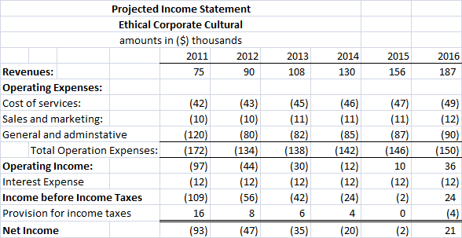
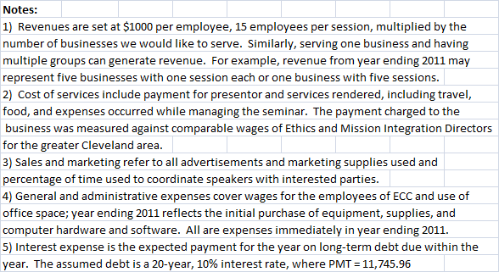

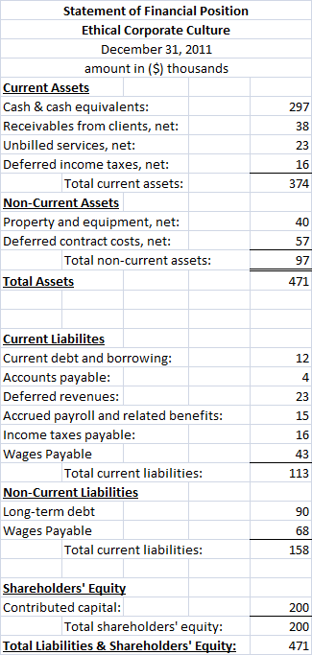

Appendix B
(Resources)
Alpert, Stephen. Federal Sentencing Guidelines – 1991 Federal Sentencing Guidelines for Corporations. Oct 1992. <http://findarticles.com/p/articles/mi_m4153/is_n5_v49/ai_13527098>
Cuyahoga County Transition Advisory Group. Proposed Cuyahoga County Code of Ethics. Nov 1, 2010. <http://charter.cuyahogacounty.us/pdf_transitioninfo/en-US/COERecommendations.pdf>
DiNorcia, Vincent. Company website <http://dinorcia.net/>
Employment Situation. (2010 November). [Cleveland area]. Federal Reserve Bank of Cleveland. Retrieved from http://www.clevelandfed.org/research/data/regional/charts/chart7.cfm?state1=1&state2=7&state3=4&state4=34&selectUS=&startDate=1/1/2009&endDate=12/11/2010&datatype=2&subdataId=0
Ethical Leadership Group. Company website <http://www.ethicalleadershipgroup.com/>
Fortune 500 2009: Fortune 1000 Companies 1-100. Fortune. Retrieved from http://money.cnn.com/magazines/fortune/fortune500/2009/full_list/
Gordon, Alexander. Ethics Training Program for Employees. Ezine Articles. <http://ezinearticles.com/?Ethics-Training-Programs-For-Employees&id=395220>
Hess, David; McWhorter, Robert; Fort, Timothy. 2004 Amendments to the Federal Sentencing Guidelines and Their Implicit Call for a Symbiotic Integration of Business Ethics, 2006. Bnet. <http://findarticles.com/p/articles/mi_qa4048/is_200601/ai_n17173618/>
Institute of Management Consultants USA. Website <http://www.imcusa.org/>
Johnson, Craig. Meeting the Ethical Challenges of Leadership: Casting Light or Shadow, Edition 3. Sage Publications, Thousand Oaks, CA; 2009.
Josephson Institute. Company website <http://josephsoninstitute.org/business/services/consulting.html>
McWhorter, Robert; Fort, Timothy. 2004 Amendments to the Federal Sentencing Guidelines and Their Implicit Call for A Symbiotic Integration of Business Ethics. Fordham Journal of Corporate Financial Law; 2006. <http://findarticles.com/p/articles/mi_qa4048/is_200601/ai_n17173618>
The Ohio Grantmakers Forum, et al. (2004 February) Framing Conversations for Northeast Ohio, 9. Retrieved from http://www.scribd.com/doc/8528739/NEO-Diagnostic-Study.
Pfizer, Inc. 2009 Financial Report. Pfizer, Inc. Retrieved from http://media.pfizer.com/files/annualreport/2009/financial/financial2009.pdf
Search Results for “Cuyahoga County.” The Plain Dealer. Search executed 2010, Novemeber 30. <http://search.cleveland.com/cuyahoga+county?date_range=m2>
SBA. Write a Business Plan. U.S. Small Business Administration. <http://www.sba.gov/smallbusinessplanner/plan/writeabusinessplan/SERV_WRRITINGBUSPLAN.html>
Whistleblower Named Year’s Most Influential person in Business Ethics. 2010, January 8. Drug Week, Expanded Reporting, 1090.
World’s Most Ethical Companies Metholodology. Ethisphere. Retrieved from http://ethisphere.com/worlds-most-ethical-companies-methodology/ on 2010, Dec ember 2010.
Wu, C.F (2010 November). The Study of global business ethics of Tainwanese enterprises in East Asia. Journal of Business Ethics, Vol. 33, 151-165.

